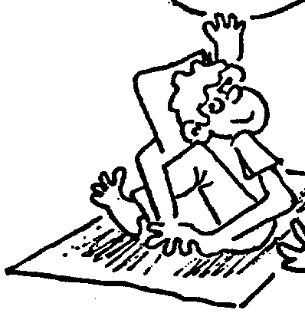
Some guidelines for asanas:
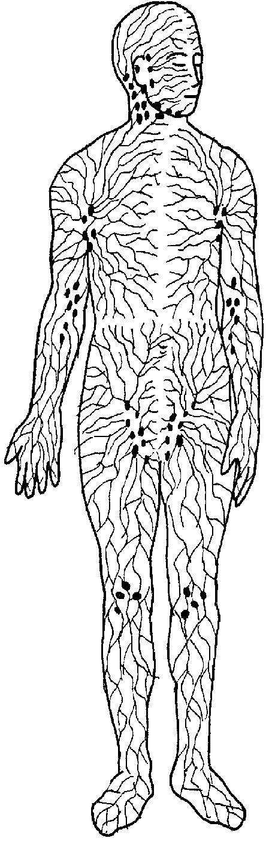
- Take a half-bath or cool shower before asanas (see instructions).

- Practise on an empty stomach (ideally wait 3 hours after meals).

- Wear supportive underwear and loose fitting clothes (at home, minimal clothing is preferable if it is not cold).

- Ensure there is no incense or cigarette smoke in the room.

- Practise on a clean blanket or mat (not bare ground)

- Practice in a quiet, private space with fresh air but no draughts.

- Perform postures slowly, with deep and relaxed breathing through the nostrils, to promote mental calmness.

- Most postures require an open left nostril for the free flow of breath.

- For more advanced asanas, a vegetarian diet is desirable.

- Warm up before asanas, stay within your limits and avoid bouncing in stretches.

- After asanas, massage the skin and remain in Corpse Posture for 3-10 minutes.

- Do not eat or drink immediately after practice (wait 20-30 mins).

- Avoid contact with cold water, air, metal, etc. for 10 mins after practice. (The body becomes sensitive to temperature change during asanas).

- A short walk alone is beneficial after asanas, rather than entering straight into a busy, noisy environment.

- Women are recommended to refrain from practice during menstruation, pregnancy and for one month after giving birth. However, Corpse Posture and meditation postures (e.g. Lotus Posture) are fine and encouraged.
The benefits of asanas:
5
2
Yoga postures have a number of unique features that set them apart from other forms of exercise:

- They relax and tone the nerves, muscles and joints, increase flexibility and promote the free flow of energy through the body.

- They require minimal physical energy and so do not create mental dullness

- They enable the practitioner to divert energy to higher centres in the body, giving control over desires and subtlety of awareness.

- Through use of the breath, they purify the blood and promote calmness, mental steadiness, concentration and depth of perception.

- Their most important benefit is their subtle effect on the glandular system. Such glands as the thyroid, thymus, pituitary, pineal gland and gonads secrete hormones into the bloodstream that affect our physical, mental and emotional states. The right combination of asanas stimulates and corrects a lethargic, under-active gland or alternatively regulates an overactive gland, giving balanced mental and physical health.

The 3 Basic Asanas

Yogamudra
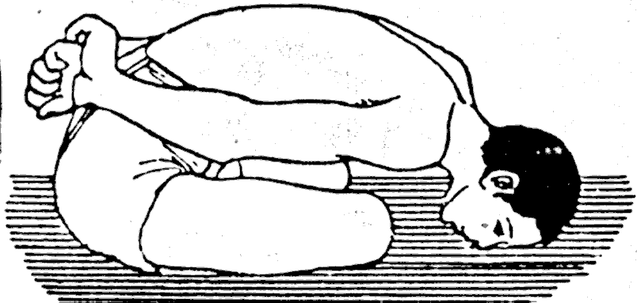
Sit with crossed legs and a straight spine. Clasp the left wrist with your right hand behind your back, the middle finger and thumb touching each other. Inhale, then exhale slowly, bending down to touch the ground with the forehead and nose. Hold the breath out and maintain the position for 8 seconds. Inhale slowly, rising up. Practise 8 times.
This posture is good for the back and internal organs, especially the heart and lungs. It is also one of the best yoga poses for female diseases.

Cobra posture
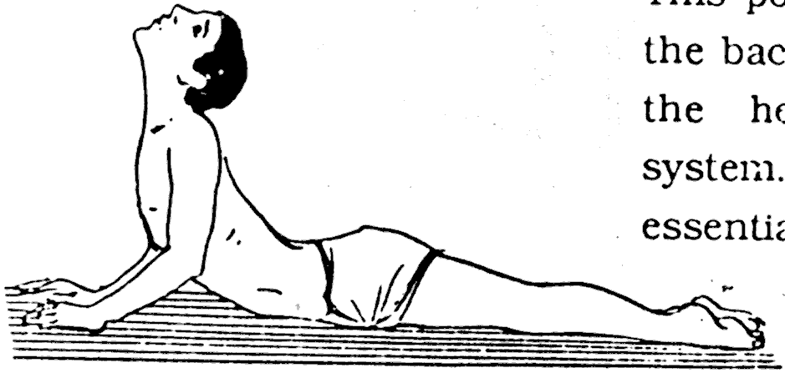
Lie on your stomach, with your forehead on the ground, and your hands either side of your shoulders. Inhale slowly, look towards the ceiling and raise the chest, using the strength in the back and not the arms. Keep the navel on the ground. Hold the breath in and maintain the position for 8 seconds. Exhale slowly and return to the original position. Practise 8 times.
This posture, used as a counter-posture for Yogamudra, cures many defects of the back and spine, and is good for the heart, lungs and digestive system.

Long Salute
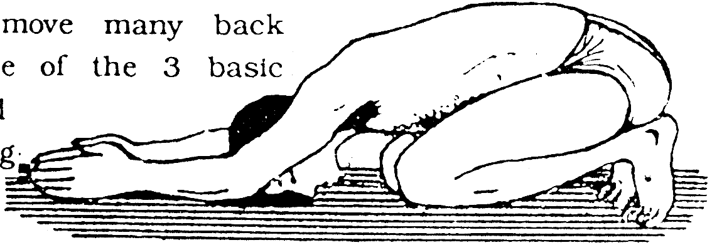
Kneel down and sit on your heels, with the toes bent forward. Inhale slowly, straighten the arms to the sides and raise them above the head, bringing the palms together. Exhale slowly, bending the head and arms forward, always keeping the arms straight beside the ears. Push the hands forward along the ground until you touch your forehead to the floor. Keep your bottom on your heels. Hold the breath out and maintain the position for 8 seconds. Then inhale slowly and rise to the original position. Repeat 8 times.

Long Salute strengthens the back and stomach, reducing abdominal fat. It also promotes regular menstruation in women.

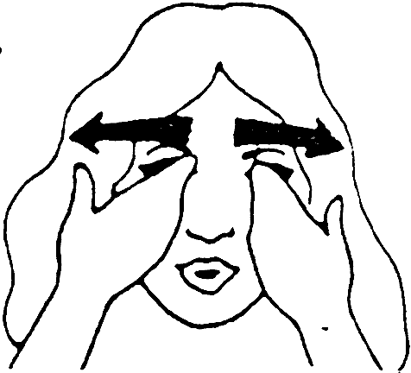
Massage
After your asanas, don't forget the massage. Asanas stimulate the skin’s sebaceous glands to secrete their natural oils. The massage rubs these beneficial oils back into the skin, keeping it soft and supple. Massage also stimulates the lymph system and the entire nervous system. After massage, stay in Corpse Posture for 3-10 minutes, a rest that can be deeper than sleep.
Through regular practice of Yoga, you will be relaxed
and revitalised in body, mind and spirit.
3
4

